1) Change Physical Alternatives for all Scenarios to “100% Capture Inlets”.

-Open Scenario Manager.
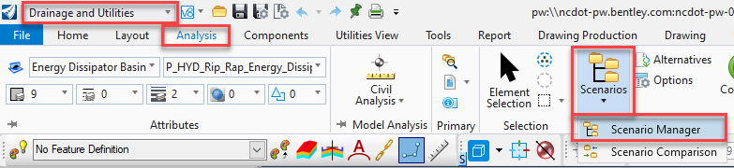

-One Scenario at a time, right-click on a Scenario and select Properties.
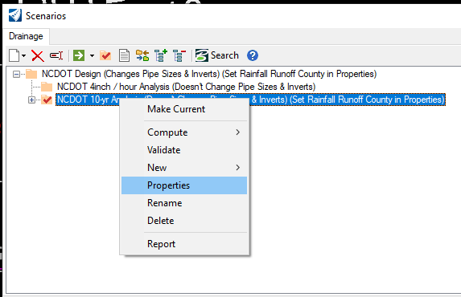

-Drainage and Utilities Properties will open. Choose the Drainage tab. Left-click on “Physical” row to access dropdown menu. Set to “100% Capture Inlets”.
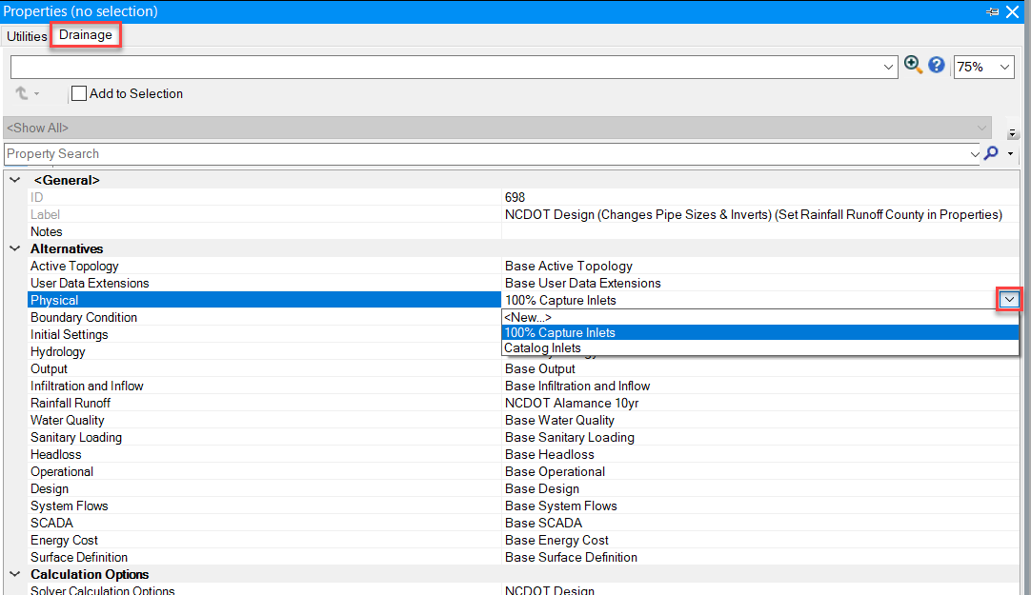

***Repeat for all Scenarios.***
2) Delete the “Catalog Inlets” Physical Alternative.

-Open Alternatives.
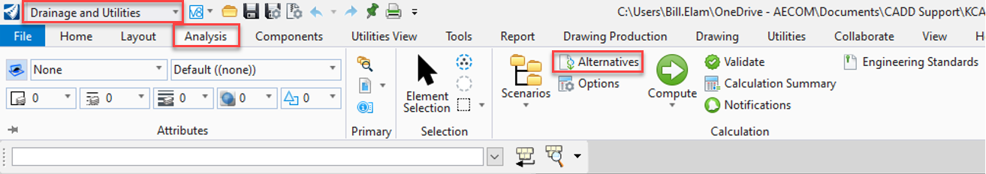

-Open “Physical” by double-clicking or clicking on +. Right-click on Catalog Inlets and Delete.
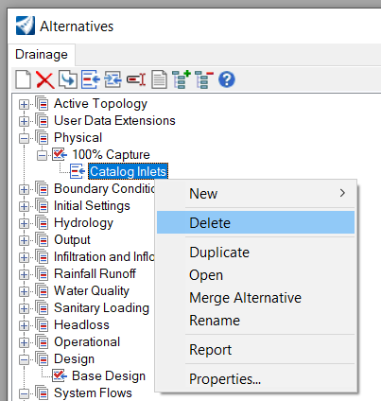

3) Modify “parent” Physical Alternative.

-Right-click on “100% Capture” and Rename "NCDOT - see Notes for Instructions (right-click and open Properties)”
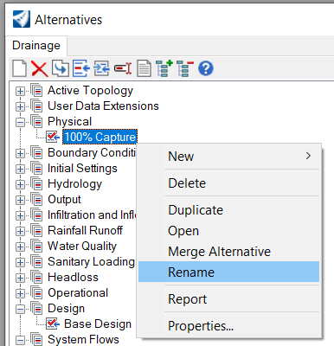

In this step, instructions will be pasted into the physical alternative that was just renamed. The instructions are for users to follow each time they switch between the 4” / Hour scenario, and either the Pipe Design scenario or the Pipe Analysis scenario.

-Right-click on newly-renamed Alternative and open Properties. Click on “Notes” and left-click on “…” at far right of field to open Notes. Copy/paste the following into Notes pop-up box:

Click Notes and click "..." at far right to open.
Copy/Paste or Screenshot these Notes to follow step-by-step.
This pop-up and the Properties pop-up will need to be closed before Step 1.

1) Open/Reopen Alternatives; 2) Double-click new "NCDOT" Alternative to open; 3) Select Catch Basin tab at top; 4) Right-click Inlet Type column header; 5) Use Global Edit to change Value before running Scenario (if running 4inch / hour Spread Analysis Scenario > set “Value” to “Catalog Inlet”. If running Pipe Design or Pipe Analysis Scenario > set “Value” to “Full Capture” OR “Percent Capture”. If using “Percent Capture”, use Global Edit to change Capture Efficiency (%) column “Value” to 100.)

User MUST global edit the inlet type under the Catch Basin tab to Full Capture or 100% Capture when running a Pipe Analysis or Pipe Design Scenario. User MUST global edit the inlet type under the Catch Basin tab to Catalog Inlet when running the 4in/hour Spread Analysis Scenario. The Full / 100% Capture inlets ensure all water that reaches each surface inlet is added to the flow in the pipe, resulting in a conservative pipe design. The Catalog Inlets activate calculations that determine the flow captured by the inlet v/s the bypass flow.

-Select OK to close Notes pop-up box.

4) Follow Instructions to change Inlet Type. The steps below are an illustration of the instructions just pasted into the Notes field in the step above.

-Close Properties and open/reopen Alternatives.
-Double-click newly-renamed “NCDOT” Alternative to open.
-Select Catch Basin tab.
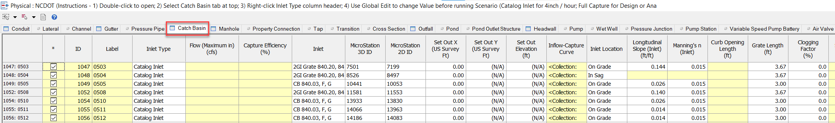
(*Tip – leave this window open to quickly change Inlet Type when switching between Scenarios)

-Right-click Inlet Type column header and select “Global Edit…”.
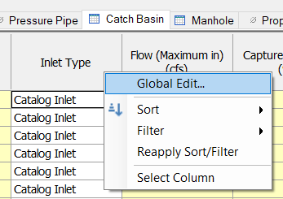

-If running 4inch / hour Spread Analysis Scenario > set “Value” to “Catalog Inlet”. If running Pipe Design or Pipe Analysis Scenario > set “Value” to “Full Capture” OR “Percent Capture”. If using “Percent Capture”, use Global Edit to change Capture Efficiency (%) column “Value” to 100.
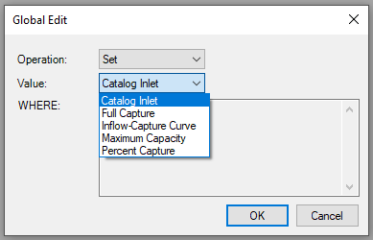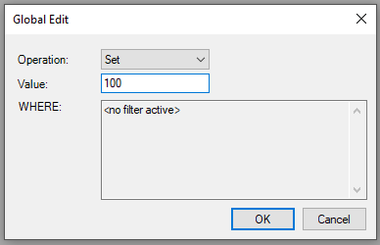

-Run Scenario.

***Please note: Be sure to change Inlet Type *before* running a different Scenario.***

